A user-centered design and analysis of an electrostatic haptic touchscreen system for students with visual impairments

Visual impairment teaching software design User experience

【Summary】：

Due to the visual features of graphics, charts, tables, and graphs, visually impaired students face unique challenges when learning mathematical concepts. Our user-centric design approach provides an intuitive interface for the visually impaired and lays the foundation for demonstrating the potential of the mathematical data shown in the device's graphics.

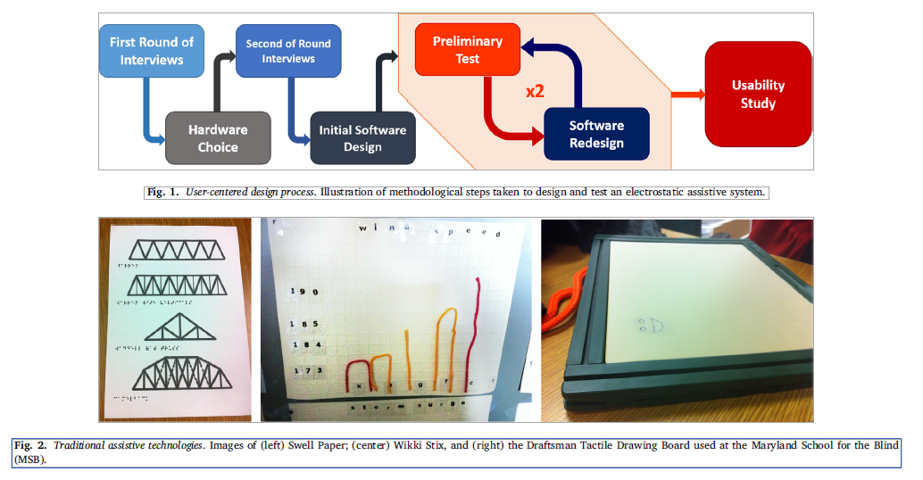

【Software iteration process】:

**Initial software design:** The initial software design had three goals: (1) to promote ease of programming and administering lessons for a sighted teacher, (2) to investigate static UI features that provide spatial orientation for the user, and (3) to create the software for the ﬁrst preliminary test.

Note1: (In order to meet the needs of the educators at MSB, we designed a system for teaching lessons in the format of a haptic slideshow, in which each slide contained haptic images. This system allowed teachers to navigate through slides one at a time via navigational buttons at the user’s own pace. Additionally, to address the teachers’ frustrations with having to painstakingly program lessons into devices, the software was designed to support the rapid creation of commonly used mathematical objects like circles, lines, and rectangles. Secondly, we implemented a feature to help users with visual im- pairments ﬁnd static UI elements. )

Note2: (we added objects that comprise compo- nents of a graph such as dots, circles and regular polygons, lines of varying thicknesses, and graph axes. Shapes had two styles of haptic representation: (1) a haptic eﬀect within their whole area, and (2) a haptic eﬀect only on their outline. In addition to diﬀerent shape rep- resentations, we implemented three diﬀerent textures. These included: (1) Granite, a temporal eﬀect Tanvas designed to feel like granite, (2) PeakAndGradient, a temporal eﬀect we designed to create peaks and valleys in intensity, and (3) HexHole, a temporal eﬀect we designed to feel like a mesh of strong intensities with regular gaps.)

**Preliminary test 1:** A ﬁrst preliminary test was conducted with an adult male who is totally blind, holds a Ph.D. in Mathematics, and served as treasurer of the Science and Engineering Division of the NFB. Throughout the test, the participant was asked to ﬁrst provide his own opinion of each haptic feature and then critique the feature based on his expert knowledge of device preferences of members of the blind community. Based on the participant’s feedback, parallel prototypes for a variety of software features were developed.

**Software redesign 1:** The ﬁrst software redesign was motivated by three primary recom- mendations: (1) to create stronger haptic textures, (2) to make the cor- ners of shapes more pronounced, and (3) to determine the optimal thick- ness of a haptic line.

**Preliminary test 2:** We conducted a second round of testing with a Senior Staﬀ En- gineer from the National Library for the Blind and Physically Handi- capped, who was the expert-user from the second round of interviews.

**Software redesign 2:** Omitted

**Usability study:** Multiple experiments on simple positioning tasks.

Main indicators: accuracy (correctness of response) and efficiency (time from initial contact with the device to feedback)

Procedure：

The protocol consisted of 30 slides displayed on the device, each with a single haptic dot mea- suring 120 pixels in diameter and located at one of 30 evenly-spread, predetermined locations on the screen. The participants were asked to locate the dot on the screen with their ﬁnger and verbally aﬃrm that they had found it. The participant was given 45 s per slide to complete the task before being prompted for a response or allowed to give up.

Results:

The accuracy rate is 69.83%, and the average time is 15.34 s

Analyze:

accuracy analysis：Divide each participant's test into five equal parts (remove a single participant who is not proficient in the task in 30 trials) and perform linear regression analysis. The results show that most people with visual impairments can use Electrostatic touch screens perform simple tasks and can quickly improve their task performance.

eﬃciency：The method is the same as above. The main purpose of the system is to convey the graphic information to the user accurately instead of quickly. Therefore, improving efficiency is not more important than increasing accuracy.

strategy analysis：To analyze participants' exploration of electrostatic touch screens, we first label each participant with one of four strategies: (1) systematic sweeping motions, (2) attempted sweeping motions with sign gap gaps, and (3) rapid unstructured screen exploration with a focus on corners, and (4) no discernible strategy The average accuracy rate of each strategy is listed in the table. We can see that 50% of the participants intuitively used the strategy that produced more than 90% accuracy rate.

location-based accuracy analysis：As shown in FIG. 7, the accuracy of points at the corners of the screen tends to be higher than the accuracy of points near the center of the screen. In addition, among these 12 participants, 11 participants had higher average accuracy rates at these three corner points than at all points.

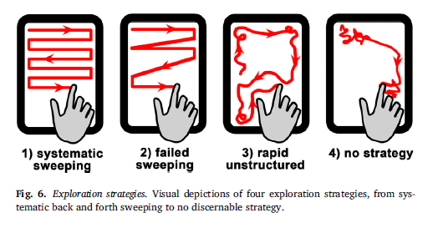

【Contribute】：

(1) the device in this study is a portable, standalone system with a powerful operating system, (2) we received feedback from a larger and more varied group of users, all of whom have profound visual impairments, and (3) we implemented an iterative, user-centered design process in order to develop an assistive device which is optimized for people with visual impairments.

【Subjective analysis】：

**Advantage:**

(1) Design the entire system through repeated iterative investigations.

(2) Fully refer to the design opinions of the visually impaired.

(3) The analysis method in the data analysis stage is worthy of reference.

(4) The design of the tactile elements proposed in the article is very useful for reference, such as shape, width, and touch intensity.

(5) The visual characteristics of graphics, charts, tables and graphs, visually impaired students face unique challenges when learning mathematical concepts. Our user-centric design approach provides an intuitive interface for the visually impaired and lays the foundation for demonstrating the potential of the mathematical data shown in the device's graphics.

**Next:** Should continue to study the practicality of the system on specific diagrams and mathematical problems.

